# Parts of Speech Detector for Urdu Language



**Group Members:**

Ishma Hafeez 21k-4688

Bilal Abdul 21k-4522

___________________________________________________________________________

**Introduction:**

The project is basically about detecting parts of speech in Urdu. You can enter Urdu data like a word, a sentence, and an article. We have to figure out the part of speech of every word in the sentence, article, or the word itself entered by the user.

**Methodology:**

- Sentence will be entered by the user in the input file.

- The program will read this sentence from the file.

- This data is saved in array as well as other list of part of speeches

- We will use searching operations to see in which part of speech the individual words from input array lie in using a substring checker function we made.

- Then it will write the data in output files with respect to its property of speech.

**Outputs:**

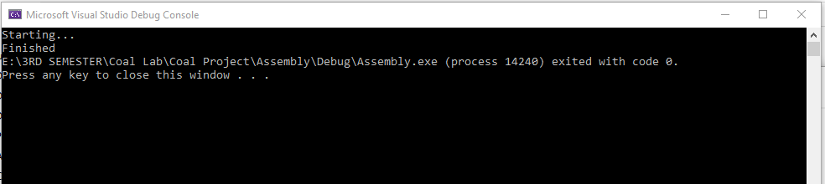

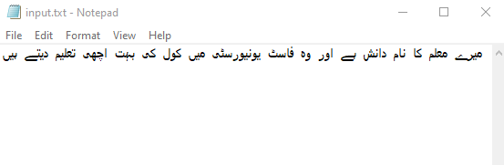

Input File

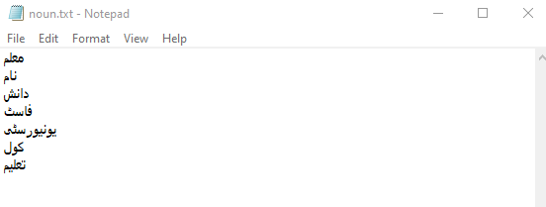

Output File: Nouns

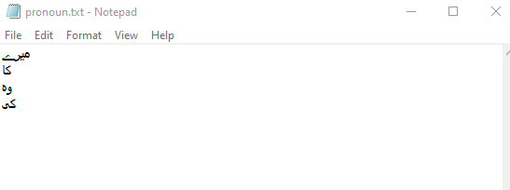

Output File: Pronouns

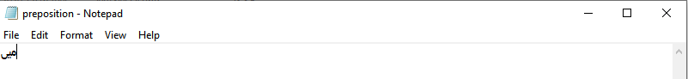

Output File: Prepositions

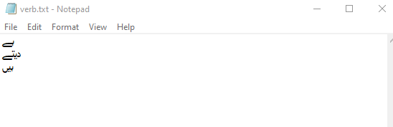

Output File: Verbs

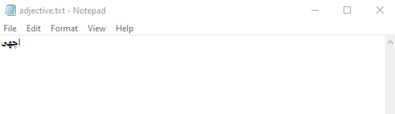

Output: Adjectives

Output: Adverbs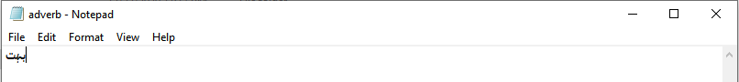

**Conclusion:**

In this project, we explored filing, string primitives, and shift operations. We also explored how to work with Unicode in assembly language.